**CHAPTER 1**

**INTRODUCTION**

**1.1 OVERVIEW:**

Rapid urbanization leads to increasing population and building density in metropolitan cities. Construction activities, such as blasting, demolition, piling, compaction, construction machinery, and so on, may expose a large number of nearby structures and facilities to intolerable levels of ground-borne vibrations. The effects of such construction-induced vibrations have been studied by researchers and practitioners for a long time.

Over the past 50 years, the role of sensors and sensing systems has grown considerably in the design, construction, and management of civil infrastructure system. Growth in the application of sensors to monitoring operational structures has occurred due in large part to the rapid transformation of sensors into high-performance measurement devices capable of measuring the behavior of structures at global and local scales. These attributes have led to the adoption of sensing systems to track the progress of infrastructure construction. On the other hand, many types of equipment and processes (such as scientific laboratories, hospital operating theaters, and microelectronic operation) are extremely sensitive to vibrations that are lower by orders of magnitude than those limits defined for structures. For continuous vibrations, the allowable thresholds are only 40% of the permissible levels of intermittent vibrations. A simple monitoring operation takes occasional measurements at the concerned locations from time to time, while more advanced monitoring requires continuous measurement with real-time data processing, remote data display, and automatic alarm functions. Desirable characteristics of an advanced construction-induced monitoring system include: easy installation and operation, high sampling frequency, embedded algorithms for vibration impact assessments concerning various vibration indicators, real-time data processing capability, graphical user interface that displays vibration impact assessment results to contractors. Given the highly specialized vibration monitoring devices, processes, and requirements, contractors often need to turn to third-party vibration consultants or specialists for help. Portable sensors and user-friendly monitoring system can considerably facilitate construction workers in their daily practice.

The selection of an appropriate sensor should consider the needs of monitoring applications. The collected measurement results should be processed and compared with pre-specified vibration criteria continuously. Therefore, a construction-induced vibration monitoring system should have the capabilities of real-time data acquisition and processing, so that contractors can know vibration levels in real time and control the potential occurrence of negative impact in a timely manner.

Traditional tethered sensory systems have been successfully implemented to monitor many civil engineering structures in operational and extreme conditions. However, their deployment is typically complicated and costly. Due to the maturity of microelectromechanical systems (MEMS) technology, wireless monitoring systems using MEMS sensors have been explored as a promising alternative to the wired system.

MEMS based wireless sensors integrate autonomous data acquisition, data processing algorithms, and wireless data transmission. Compared with MEMS-based wireless sensors integrate autonomous data acquisition, data processing algorithms, and wireless data transmission. Compared with wired systems, wireless sensors provide comparable functionality with considerably lower price, smaller size, and easier installation.

**1.2 Design of IoT Sensing System:**

The system IoT sensing system for construction-induced vibration monitoring aims to use non-expensive hardware and general-purpose software to accommodate technological conditions in different measurement environments. Wireless transmission is achieved via 4G signal provided by a USB Internet dongle

A differential radar interferometry technique was used in for assessing risks of both structural instability and land displacement. In ambient vibration tests, i.e., tests where the vibration is caused by operating conditions and is not forced onto the structure, were performed on a heritage building. A survey of the application of ambient vibration tests and operational modal analysis to heritage structures is provided in showing the considerable interest and relevance of such a topic.

Finally, of great relevance are the hypogeal archeological sites, which are frequent in many Italian regions. In this case, due to the close interaction of the cavity with the surrounding soil, the preservation of the site from environmental and seismic risk also requires geotechnical aspects to be taken into due consideration.

**1.3 Development of the Monitoring System:**

The system is developed to enable distributed monitoring of acceleration in structures and geotechnical systems. Therefore, the system design requirements are low cost, fast prototyping, the connection of sensors to an online platform following the IoT paradigm, and flexibility for integrating different functions. Furthermore, the functional requirements of the sensor are the easy deployment in multiple positions for areal heterogeneity in the considered site, and the ability to detect relevant vibrations of a structure caused by anthropic activities, e.g., rail and vehicle traffic, and by earthquakes. By applying a rapid prototyping approach, off-the-shelf components were selected in the design phase, thus limiting the development of analog electronic devices. This approach enabled the development of a working prototype in a short period of time. It also provided flexibility, since the modular architecture allows us to replace the specific sensor module with a different module for sensing another physical quantity, or to implement a multi-sensor platform.

The system is comprised of several self-contained and battery-powered sensor nodes and a receiver node. Each of the sensor nodes are equipped with a MEMS triaxial accelerometer, a low-power Long Range (LoRa) radio module for data transmission, and a Global Positioning System (GPS) receiver, which is used for time synchronization through the 1-pulse-per-second (1PPS) signal. The choice of using the GPS receiver to implement the time synchronization functionality is motivated because it provides greater accuracy and coverage than other potential solutions, such as ultra-wideband radio and inductive links while promoting fast prototyping thanks to the wide availability of commercial modules.

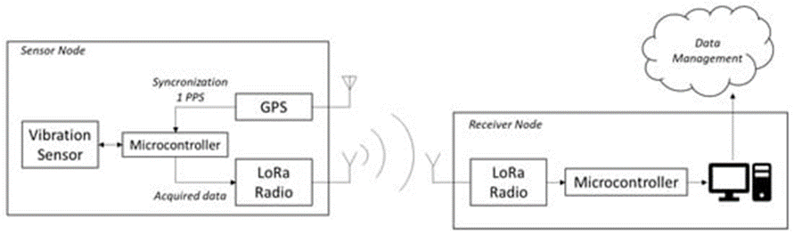

Fig 1.1: Block diagram depicting the architecture of the developed system**.**

In the developed system, each sensor node is synchronized independently using its own GPS receiver. This eliminates the need for exchanging synchronization messages between nodes. The synchronization of each sensor node is performed by reading the GPS navigation message sent from the satellites and received by the GPS receiver. This message contains a Coordinated Universal Time (UTC) timestamp.

**1.4 REAL TIME BRIDGE DATA:**

The structural stability of the cantilever base vibration sensor has to be an optimization crossover between the thickness of the cantilever and the inherent strength of the cantilever. In order to measure the vibrations and associated frequencies that are developed in the bridge, the designed cantilever vibration sensor that is proposed shall be installed in the bridge slab should itself be able to sustain and bear the load that it shall be subjected to and at the same time, maintain its function as a vibration sensor. The primary live loads on bridge spans are due to moving traffic. The heaviest loads are those produced by large transport trucks.

**CHAPTER 2**

**LITERATURE REVIEW**

Gian Michel.et.al; implemented about the collapsed part of the bridge essentially comprised an individual self-standing structure spanning 171 m and two simply-supported connecting Gerber beam systems, each spanning 36 m from the self-standing structure to the adjacent portions of the bridge. This paper aims to reminisce the complete story of the bridge, from the Italian construction boom in the 1960s to some of the issues that soon arose thereafter: the strengthening intervention in the 1990s, the subsequent structural monitoring and, finally, the strengthening project never brought to fruition. Potential reasons for the collapse are discussed, together with some of the possible inadequacies of the bridge, its maintenance and loading history based on critical reflection, comparison with specific features of bridge construction practice today and results obtained using numerical models with different levels of refinement. Since the entire matter (specifically the debris) was considered classified by the investigating magistrate in the immediate aftermath of the bridge collapse, this work is based entirely on publicly available material. Keywords: Morandi Bridge; structural collapse; forensic engineering; AEM modeling.

[Davide Brunelli](https://www.researchgate.net/scientific-contributions/Davide-Brunelli-2151423946)**.**et.al**;** implemented a system that a low-cost wireless sensor node specifically designed to support modal analysis over extended periods of time with long-range connectivity at low power consumption. Our design uses very cost-effective MEMS accelerometers and exploits the Narrowband IoT protocol (NB-IoT) to establish long-distance connection with 4G infrastructure networks. Long-range wireless connectivity, cabling-free installation and multi-year lifetime are a unique combination of features, not available, to the best of our knowledge, in any commercial or research device. We discuss in detail the hardware architecture and power management of the node. Experimental tests demonstrate a lifetime of more than ten years with a 17000 mAh battery or completely energy-neutral operation with a small solar panel (60 mm x 120 mm). Further, we validate measurement accuracy and confirm the feasibility of modal analysis with the MEMS sensors: compared with a high-precision instrument based on a piezoelectric transducer, our sensor node achieves a maximum difference of 0.08% at a small fraction of the cost and power consumption.

Jetmir Haxhibeqiri.et.al;design a system thatLoRaWAN is one of the low power wide area network (LPWAN) technologies that have received significant attention by the research community in the recent years. It offers low-power, low-data rate communication over a wide range of covered area. In the past years, the number of publications regarding LoRa and LoRaWAN has grown tremendously. This paper provides an overview of research work that has been published from 2015 to September 2018 and that is accessible via Google Scholar and IEEE Explore databases. First, a detailed description of the technology is given, including existing security and reliability mechanisms. This literature overview is structured by categorizing according to the following topics: (i) physical layer aspects; (ii) network layer aspects; (iii) possible improvements; and (iv) extensions to the standard. Finally, a strengths, weaknesses, opportunities and threats (SWOT) analysis is presented along with the challenges that LoRa and LoRaWAN still face.

Huaping Wang et.al; implemented a system that the Optical fiber sensors are the most promising technique in monitoring physical and chemical variables of civil structures. For the brittle material characteristics, a bare sensing fiber is prone to breakage under the shear or torsional action existed in the construction and operation. To guarantee the survival and long-term service of the sensors, the packaging measure is particularly significant. This treatment generates an inter medium layer between the sensing fiber and the monitored structure, which leads to the strain of the host material not entirely transferred to the sensing fiber for a portion of strain loss in the transferring path. To correct the error and improve the measurement accuracy, strain transfer theory is developed to establish the quantitative strain relationship between the sensing fiber and the host material. It aims to demonstrate the advance, the application and the challenge of strain transfer theory and provide scientific guidance for the better understanding of the multi-layered sensing model and the theoretical instruction for the optimum design, calibration and measurement accuracy enhancement of optical fiber sensors.

[Tommaso Polonelli](https://www.researchgate.net/profile/Tommaso-Polonelli) et.al; implemented a system that a low-cost wireless sensor node specifically designed to support modal analysis over extended periods of time with long-range connectivity at low power consumption. Our design uses very cost-effective MEMS accelerometers and exploits the Narrowband IoT protocol (NB-IoT) to establish long- distance connection with 4G infrastructure networks. Long-range wireless connectivity, cabling-free installation and multi-year lifetime are a unique combination of features, not available, to the best of our knowledge, in any commercial or research device. Further, we validate measurement accuracy and confirm the feasibility of modal analysis with the MEMS sensors: compared with a high-precision instrument based on a piezoelectric transducer, our sensor node achieves a maximum difference of 0.08% at a small fraction of the cost and power consumption.

[Azam Khan](https://www.researchgate.net/scientific-contributions/Azam-Khan-2195057135).et.al**;** proposed that the dataAcquisition of vibration data using off-the-shelf equipment is a costly procedure, thus constraining the research and development in developing countries. In this research, micro-electromechanical systems (MEMS) accelerometers combined with an Arduino-based data acquisition system, were used to acquire vibration data of a reinforced concrete beam at various damage levels. The recorded data, having lower and varying sampling frequency, were processed to find the fundamental frequency of the beam. The results showed good agreement with the commercially available accelerometers. To integrate the experimental and computational work, a finite element model was developed which showed good agreement with the experiment. It was found that MEMS accelerometers are cost-effective and can be effectively employed for continuous health monitoring of existing civil infrastructure.

[Prashanth Ragam](https://ietresearch.onlinelibrary.wiley.com/action/doSearch?ContribAuthorRaw=Ragam%2C+Prashanth).et.al; implemented about the Ubiquitous wireless sensor network (WSN) enables low-cost monitoring applications such as blast-induced ground vibration (BIGV) and structural health monitoring (SHM). In particular, monitoring and analyzing the ambiguous BIGV waves are essential requisite to control and protect surrounding grievous damage structures. Similarly, improving health and longevity of structures using WSN is a new facet that owes to diminish the low-cost installation. Considering the current trends in the area of development of wireless monitoring prototypes, Micro-Electro-Mechanical-Systems (MEMS) accelerometer sensors are widely prevalent owing to the small size and inexpensive. In general, BIGV waves are less intensity and low-frequency signals. Hence, it is essential to select an appropriate accelerometer to detect micro-vibration waves. The study exemplifies a summarized review of recently made MEMS-based accelerometer wireless systems for intelligent and reliable monitoring of BIGV and SHM since the last decade. This research effort focuses on the numerous adopted accelerometers and their characteristics such as sensitivity, noise density, measurement range, bandwidth, resolution, network topologies, and performance of designed systems to analyze the micro-vibration levels comprehensively.

[KaisMekki](https://www.sciencedirect.com/science/article/pii/S2405959517302953" \l "!).et.al; Implemented a system that a more than 50 billion devices will be connected through radio communications. In conjunction with the rapid growth of the [Internet of Things](https://www.sciencedirect.com/topics/engineering/internet-of-things) (IoT) market, low power [wide area networks](https://www.sciencedirect.com/topics/computer-science/wide-area-networks) (LPWAN) have become a popular low-rate long-range radio communication technology. Sigfox, [LoRa](https://www.sciencedirect.com/topics/engineering/lora), and NB-IoT are the three leading LPWAN technologies that compete for large-scale IoT deployment. This system provides a comprehensive and comparative study of these technologies, which serve as efficient solutions to connect smart, autonomous, and heterogeneous devices. We show that Sigfox and LoRa are advantageous in terms of battery lifetime, capacity, and cost. Meanwhile, NB-IoT offers benefits in terms of latency and quality of service. In addition, we analyze the IoT success factors of these LPWAN technologies, and we consider application scenarios and explain which technology is the best fit for each of these scenarios.

[Itamir de Morais](https://www.researchgate.net/profile/Itamir-Barroca-Filho-3).et.al; discussed about a system that the improvement of technological applications focused on the health context is growing. Different types of applications, such as Health Information Systems (HIS), Electronic Health Records (EHR), and e-Health and m-Health applications, are being developed. With the increasing use of technological solutions in this context, there is a need to integrate the data collected, stored, and processed in these systems. However, the heterogeneity of the data is a factor that makes this integration difficult. To mitigate this problem, middleware appears as an option. It aims to understand the current state and future trends of middleware for healthcare applications. To do so, we carried out systematic mapping of the literature on middleware for healthcare systems. This Systematic Mapping initially collected 1162 works, which after the execution of its stages, 34 works were selected for careful reading and, as a result, we present answers to the defined research questions, collected from a careful reading of the selected works. Finally, we concluded that, although there are several middleware solutions in the literature, there is no standard among these solutions, and they end up being limited to solving the problem in a specific context in the health area.

Maha Medhat.et.al**;** implemented that aNarrowband-internet of Things (NB-IoT) is a low power wide area network that contributes strongly to the revolution and expansion of the internet of things (IoT). Here, the NB-IOT random access was conducted, taking into account random access channel (NPRACH) periodicity, number of collisions, number of users, random access preamble repetitions and time taken for all system users to finalize a Random-access procedure. Simulation results have shown that appropriately choosing NPRACH periodicity values can efficiently achieve uplink channel optimization between its two signals NPRACH and NPUSCH with an acceptable number of collisions and a high number of delivered packets. Short periodicities (40ms and 80ms) show optimal results in reducing the number of collisions for both low and high traffic while all users win NPRACH and start to send data to the base station after approximately 2 second. However, short periodicities waste more uplink resources in random access, minimizing resources remaining for data transmission. Medium-length periodicities (such as 160ms and 320ms) show a promising performance that balances the two uplink physical channels. Our results demonstrate that doubling the number of users (from 40 to 80) is not a considerable factor in choosing NPRACH periodicity with different repetition values.

A. Sabato et.al; Monitoring and analyzing the integrity of structures and machinery is important for economic, operational, and mission critical reasons. In recent years, there has been growing interest in performing structural health monitoring (SHM) by monitoring structural dynamic response via micro electro-mechanical system accelerometers. In addition, the possibility of embedding these devices within a wireless sensor network and allowing measured data to be wirelessly transmitted has contributed to the development of many new applications not possible just a few years ago. These sensors, for use in SHM applications, need to detect low-amplitude and low frequency vibrations, operations which are not always feasible with the conventional low-cost sensor boards. Since the late 1990s, several accelerometer boards prototypes have been proposed for achieving accurate vibration monitoring. This paper presents a summary review of the systems developed in the ten years following 2006 with particular emphasis on the sensing characteristics, performances, and applications of the designed sensor boards for micro vibration detection and analysis.

**CHAPTER 3**

**PROJECT DESCRIPTION**

**TRANSMITTER:**

Power Supply

Lora MKR 1300

2 Axis

Weight Load Cell

Vibrator

3 Axis

Fig.3.1 Transmitter block diagram

**RECEIVER:**

Lora MKR 1300

Power Supply

Gate Way

Net Connectivity

Fig.3.2 Receiver block diagram

**3.1. Working Principle:**

The LoRa MKR 1300 gateway has many inputs channel the input has different functionality. The output can be transmitted over the transmitting antenna. If the vibrator activates from the mechanical vibration into electrical signal. This electrical signal has process by means of LoRa MKR 1300 and perform the output function which is received by another gateway present in the receiver stage. The local cell converts the variation of stress or strain is converted into it is equivalent electrical energy flows through the resist material. The resistance of material varies depends upon the application of weight, which displays the output from the receiver unit in the distance place.

Receiver consist of the same gateway which provide a proper synchronization. This lora covers the area up to 25km. Another gateway of some LoRaWAN is used to additive the coverage area. The same LoRaWAN act as a repeater which will cover the desirable range.

**3.2. Power Supply:**

A power supply is an electrical device that supplies electric power to an electrical load. The main purpose of a power supply is to convert electric current from a source to the correct voltage, current, and frequency to power the load. As a result, power supplies are sometimes referred to as electric power converters. Some power supplies are separate standalone pieces of equipment, while others are built into the load appliances that they power. Examples of the latter include power supplies found in desktop computers and consumer electronics devices. Other functions that power supplies may perform include limiting the current drawn by the load to safe levels, shutting off the current in the event of an electrical fault, power conditioning to prevent electronic noise or voltage surges on the input from reaching the load, power-factor correction, and storing energy so it can continue to power the load in the event of a temporary interruption in the source power (uninterruptible power supply). All power supplies have a power input connection, which receives energy in the form of electric current from a source, and one or more power output or rail connections that deliver current to the load. The source power may come from the electric power grid, such as an electrical outlet, energy storage devices such as batteries or fuel cells, generators or alternators, solar power converters, or another power supply. The input and output are usually hardwired circuit connections, though some power supplies employ wireless energy transfer to power their loads without wired connections. Some power supplies have other types of inputs and outputs as well, for functions such as external monitoring and control.

**3.3. 2Axis:**

The coordinate plane is organized around two axes: the x-axis running horizontally, and the y-axis running vertically. The position of a point on the plane is described by two numbers that measure the distance from the point to these two reference lines. A dual axis chart (also called multiple axes chart) uses two axes to easily illustrate the relationships between two variables with different magnitudes and scales of measurement. The relationship between two variables is referred to as correlation.

**3.4. 3Axis:**

Axis Milling – Milling is the machining process of using rotary cutters to remove material from a piece of metal, wood, foam, or plastic, to form the piece into a specific shape. 3 Axis Milling is employed when the cutting requires simultaneous controlled movement of the X, Y and Z axes.

**3.5. Vibrator:**

Vibrators are used to compact concrete on the construction site. Concrete vibrators are available in a wide range of shapes and sizes. Some Concrete Vibrators are smaller, more efficient, and run-on battery power, while others are much larger and rely on electric power.

**3 .6: LoRaWAN Specification:**

|  |  |
| --- | --- |
| Specification | LoRaWAN technology support |
| Standard | LoRa Alliance |
| Operational Frequency | 868,915MHz |
| Data Rate (Kbps) | 0.3-0.50(Europe),  0.9-100(US) |
| Identity header size | 4bytes |
| Payload size | 51-222 bytes |
| Addressing | UL:Broadcast, DL:Unicast |
| Topology | Star |

Table 3.1: LoRaWAN specification table

**3.7. LoRaWAN Node:**

LoRaWAN is a low-power wide area networking protocol built on top of the LoRa radio modulation technique. It wirelessly connects devices to the internet and manages communication between end-node devices and network gateways. Usage of LoRaWAN in industrial spaces and smart cities is growing because it is an affordable long-range, bi-directional communication protocol with very low power consumption devices can run for ten years on a small battery. It uses the unlicensed ISM (Industrial, Scientific, Medical) radio bands for network deployments. LoRaWAN is a low-power, wide area networking protocol built on top of the LoRa radio modulation technique. At the most fundamental level, Radio protocols like LoRaWAN are simple. An enterprise grade LoRaWAN backend from the makers of the things.

An end device can connect to a network with LoRaWAN in two ways:

Over-the-air Activation (OTAA): A device has to establish a network key and an application session key to connect with the network.

Activation by Personalization (ABP): A device is hardcoded with keys needed to communicate with the network, making for a less secure but easier connection.

**3.8. Weight Load Cell:**

A load cell is essentially a force transducer or force sensor. It is used principally to measure weight. And although they can be used to measure other forces such as torque, compression, pressure, etc. In the airline industry, weight is money. Every additional pound requires more fuel to lift, so making sure there’s enough gas in the tanks means knowing what the aircraft weighs. Weight distribution is another factor. Too much at the back and the aircraft flies’ nose-up, altering the angle of attack and consuming more fuel. As the force applied to the load cell increases, the electrical signal changes proportionally.

**3.9. Gateway:**

A computer that sits between different networks or applications. The gateway converts information, data or other communication from one protocol or format to another. A router may perform some of the functions of a gateway. An internet gateway can transfer communications between enterprises often use protocols on their local-area networks (LANs) that differ from those of the internet, a gateway will often act as a protocol converts so that users can send and receive communications over the internet. A product or feature that uses proprietary techniques to link heterogeneous systems.

Bridges and gateways both are backbone devices of networking. The key difference between the two networking devices is that a bridge connects two networks together that operate under the same protocol whereas a gateway connects two dissimilar networks together that operate according to different protocols. A gateway is a piece of [networking hardware](https://en.m.wikipedia.org/wiki/Networking_hardware) or software used in [telecommunications networks](https://en.m.wikipedia.org/wiki/Telecommunications_network) that allows data to flow from one discrete network to another. Gateways are distinct from [routers](https://en.m.wikipedia.org/wiki/Router_(computing)) or [switches](https://en.m.wikipedia.org/wiki/Network_switch) in that they communicate using more than one protocol to connect multiple networks and can operate at any of the seven layers of the [open systems interconnection](https://en.m.wikipedia.org/wiki/OSI_model) model (OSI).

**3.10. Net Connectivity:**

Wireless has taken a huge leap in usage thanks to a huge improvement in its usability over the years That’s good for many portable devices such as laptops, smart phones, etc. But for people using desktops, a wireless adapter may not be included. Or, you may to have a more stable wireless connection than the one you currently have.

Bridging an internet connection refers to making connections between different ports that will be used by your computer, such as ethernet and wireless. Bridging an internet connection refers to making connections between different ports that will be used by your computer, such as ethernet and wireless. Shown in this article are simple steps that you can use to create your own bridged connection.

A network bridge is a computer networking device that creates a single, aggregate network from multiple communication networks or network bridging. Bridging is distinct from routing. Network bridge is a feature that has been part of windows for a long time. A bridge allows you to connect two or more network segment together allowing devices to join the network when it’s not possible to connect them directly to a router switch.

**3.11. Cloud:**

The cloud is mainly responsible for data processing, storage and providing APIs to the applications. In order to ensure the scalability of the system, the cloud is divided into two parts, i.e., LoRa server and service server. The gateway communicates with the LoRa server directly.

**CHAPTER – 4**

**HARDWARE DETAILS**

**4.1. MKR 1300 LoRa:**

MKR WAN 1300 is a powerful board that combines the functionality of the MKR Zero and LoRa connectivity. It is the ideal solution for makers wanting to design IoT projects with minimal previous experience in networking having a low power device. The board's main processor is a low power Arm Cortex-M0 32-bit SAMD21, like in the other boards within the Arduino MKR family. The Wi-Fi and Bluetooth connectivity is performed with a module from u-box, the NINA-W10, a low power chipset operating in the 2.4GHz range. On top of those, secure communication is ensured through the Microchip ECC508 crypto chip. Besides that, you can find a battery charger, and a direction able RGB LED on-board. Arduino MKR WAN 1300 has been designed to offer a practical and cost-effective solution for makers seeking to add Lo-Ra connectivity to their projects with minimal previous experience in networking. The design includes the ability to power the board using two 1.5V AA or AAA batteries or external 5V. Switching from one source to the other is done automatically. A good 32-bit computational power similar to the MKR ZERO board, the usual rich set of I/O interfaces, low power Lo-Ra communication and the ease of use of the Arduino Software (IDE) for code development and programming. All these features make this board the preferred choice for the emerging IoT battery-powered projects in a compact formfactor. The USB port can be used to supply power (5V) to the board. The Arduino MKRWAN 1300 is able to run with or without the batteries connected and has limited power consumption.

ARDUINO MKRWAN 1300 is a powerful board that combines the functionality of the MKR Zero and LoRa connectivity. It is the ideal solution for makers wanting to design IOT projects with minimal previous experience in networking having a low power device. The Arduino MKR WAN 1300 board provides a practical and cost-effect solution to add LoRa connectivity to projects requiring low power. This open-source board can be connected to the Arduino IOT cloud, your own LoRa network using the Arduino LoRa PRO Gateway, existing LoRaWAN infrastructure like the things network, or even board using the direct connectivity mode.

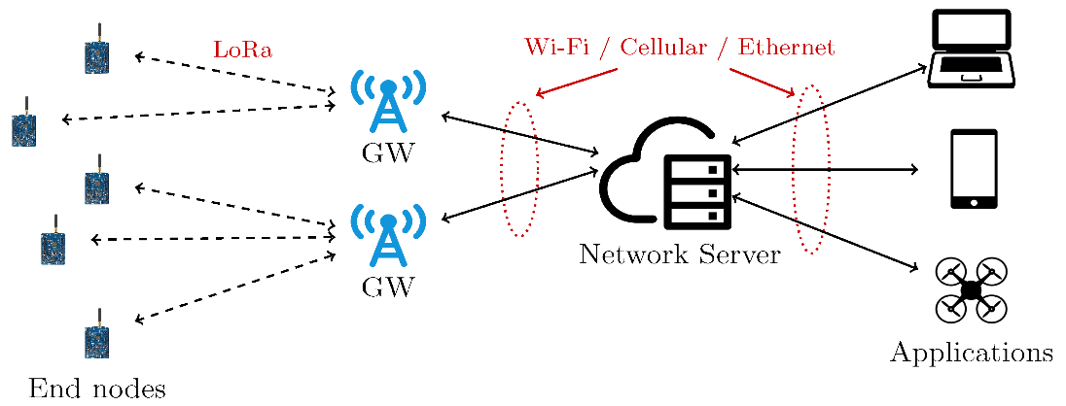

Fig .4.1. LoRaWAN security block diagram

**4.2. LoRaWAN Security:**

Security is a primary concern for any mass IoT deployment and extremely important for any LPWAN. LoRaWAN utilizes two layers of security: one for the network and one for the application. The network security ensures authenticity of the node in the network while the application layer of security ensures the network operator does not have access to the end user’s application data.

Accordingly, the LoRaWAN specification defines two layers of cryptography. A unique 128-bit Network Session Key shared between the end-device and network server. A unique 128-bit Application Session Key (AppSKey) shared end-to-end at the application level

Data over LoRaWAN is encrypted twice; sensor data is encrypted by the node, and then it is encrypted again by the LoRaWAN protocol; only then is it sent to the LoRa Gateway. The Gateway sends data over normal IP network to the network server. The Network server has the Network Session Keys (NwkSkey), and decrypts the LoRaWAN data. It then passes the data to the Application server which decrypts the sensor data, using the Application Session Key (AppSKey).

This is important since LoRa Gateway operate over open frequency so can receive data from any sensor in the vicinity. Thus, it become important that the LoRa Gateways not have ability to decrypt sensor data. It is important to note that it is the LoRaWAN communication protocol that adds the encryption. LoRa transmissions by themselves are simple radio wave transmission and cannot be encrypted.

When the keys are received the device decrypts and installs the two session keys**. The practical limit for reliable transmissions of data payloads in varying conditions is 100 bytes.** While it is possible to go slightly above, 100 bytes maximum is a good working rule. LoRaWAN networks have been tested with success, with 100byte messages sent every 7 seconds over an extended period. However, in practice, anything more frequent than transmitting once a minute is not recommended. It is possible for a single gateway to handle thousands of LoRa nodes simultaneously.

**4.3. 3 AXIS:**

Axis Milling – Milling is the machining process of using rotary cutters to remove material from a piece of metal, wood, foam, or plastic, to form the piece into a specific shape. 3 Axis Milling is employed when the cutting requires simultaneous controlled movement of the X, Y and Z axes.

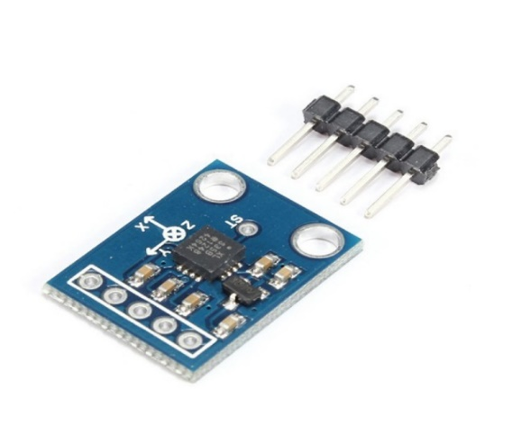

Fig:4.3: 3 axis circuit board diagram

**4.4: Vibration Sensors & Vibration Measurement Systems**

Vibration sensors are piezoelectric accelerometers that sense vibration. They are used for measuring fluctuating accelerations or speeds or for normal vibration measurement. Maintenance professionals use the sensors in order to predict the maintenance of the machinery, to reduce overall costs and increase the performance of the machinery.

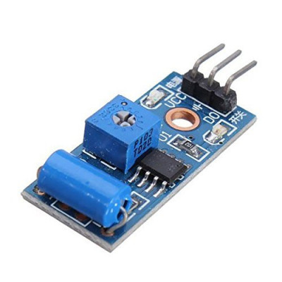

4.4: Vibration sensor

Examples of applications where the vibration sensors are used: process control systems, aerial navigation and underwater-applications. Frequency ranges from 0.2 up to 2500 Hz. The operating temperature of these sensors is between -50°C and +85°C. Fill in our[**contact form**](https://www.althensensors.com/contact/) or contact us directly: you can find the phone numbers and e-mail addresses of your [nearest location on our locations page](https://www.althensensors.com/about-althen/contact-locations/).

**4.4.1: Vibration Measurements:**

Motors and mechanical components cause vibrations in machines and plants. These vibrations should be kept as low as possible to cut back on wear and tear and avoid shutdowns. Over time, vibrations can increase due to wear and resonance. That is why many operators need to monitor the vibrations of their machines.

Vibration is measured using piezoelectric vibration sensors and matching evaluation electronics for vibration analysis. Vibration sensors are chosen based on the following criteria: required frequency range, sensitivity, and weight.

Althen provides general purpose, flexible electronic devices for vibration analysis, such as digital displays, data loggers, and long-term recorders. We also offer special software tools that we customize to suit your specific application. Our [VibroMatrix vibration measurement system](https://www.althensensors.com/measurement-systems/turn-key-measurement-systems/earthquake-vibration-measurement-systems/10161/vibromatrix-innobeamer-x2/) is a simple solution for measuring and analyzing vibration in industrial settings. This measurement system comprises a 2-channel A/D converter for IEPE vibration sensors and various software tools for PCs and Notebooks.

The stationary [VibroLine (VLE Series 1-8)](https://www.althensensors.com/measurement-systems/turn-key-measurement-systems/earthquake-vibration-measurement-systems/12066/vibroline-vle-serie-1-8-vibration-measurement-system/) vibration measurement system lets you continually monitor machine and plant vibrations in the long term. Thanks to the device’s 4-zone display, you can check the machines’ status at any time. VibroLine conforms with the DIN ISO 10816 / 20816 standards. Even if measuring vibrations is not a daily task for you, VibroLine lets you easily measure and assess vibrations – without requiring deeper knowledge of vibration measurement technology.

In addition to vibration sensors and software, Althen also provides vibration measurement related services. We can also configure your measurement system before delivery. What is more, we can handle the entire vibration measurement process for you – or train your employees on vibration measurement and the VibroMatrix and VibroLine systems.

**4.4.2. Efficient Vibration Monitoring for Plants and Machines:**

Modern vibration sensors are based on a piezo-ceramic element that is put under tension by the so-called seismic mass. This makes the mass emit a charge, which is amplified to create a voltage signal. All our vibration sensors have an integrated signal amplifier, with the exception of some high-temperature models. This makes our vibration sensors especially easy to use.

**4.5. Cortex®-M0 32-bit SAMD21 Processor:**

The Atmel | SMART™ SAM D21 is a series of low-power microcontrollers using the 32-bit ARM Cortex-M0+ processor, and ranging from 32- to 64-pins with up to 256KB Flash and 32KB of SRAM They are designed for simple and intuitive migration with identical peripheral modules, hex compatible code, identical linear address map and pin compatible migration paths between all devices in the product series. All devices include intelligent and flexible peripherals, and support for capacitive touch button, slider and wheel user interfaces. The Atmel SAM D21 devices provide the following features: In-system programmable Flash, twelve-channel direct memory access (DMA) controller, 12 channel Event System, programmable interrupt controller, up to 52 programmable I/O pins, 32-bit real-time clock and calendar, up to five 16-bit Timer/Counters (TC) and three 24-bit Timer/Counters for Control (TCC), where each TC can be configured to perform frequency and waveform generation, accurate program execution timing or input capture with time and frequency measurement of digital signals.

**4.5.1. Cortex M0+ configuration:**

|  |  |  |
| --- | --- | --- |
| **Features** | **Configurable** | **Device configuration** |
| Interrupts | External Interrupts 0-2 | 28 |
| Data endianness | Little endian or big endian | Little-endian |
| Sys Tick Timer | Present or absent | Present |
| Number of watchpoint comparators | 0,1,2 | 2 |
| Halting debug support | Present or absent | Present |
| Multiplier | Fast or small | Fast (Single cycle) |
| Single-cycle I/O port | Present or absent | Present |
| Vector Table Offset | Present or absent | Present |
| Unprivileged/privileged | Present or absent | Absent |
| Memory Protection unit | Not Present or 8region | Not Present |
| Reset all registers | Present or absent | Absent |
| Instruction fetch width | 16-bit only or mostly 32-bit | 32-bit |

Table :4.5.1.M0+ Cortex configuration

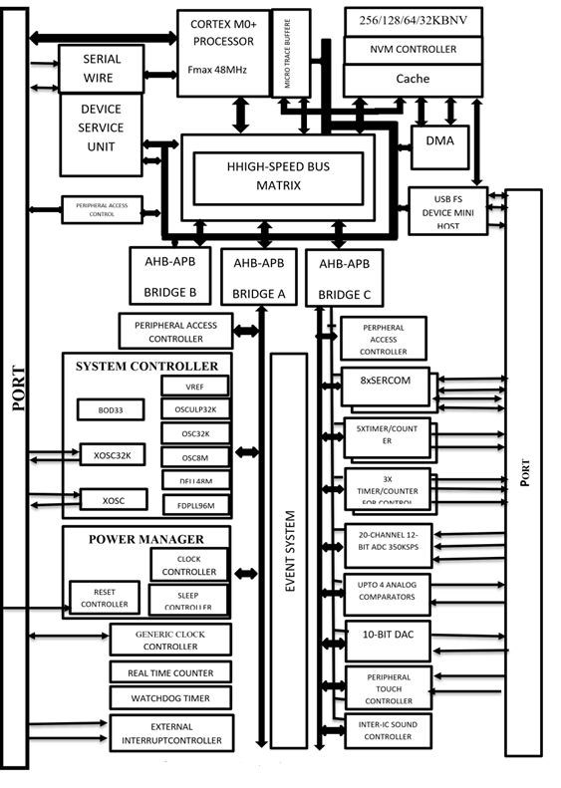

Fig :4.5: Cortex M0+ configuration

**4.6. Form Factors:**

At a glance, our vibration sensors differ almost only in size. Their form factor is primarily determined by two criteria: sensitivity and the required frequency band. To put it simply, low-frequency sensors are more sensitive and have larger casings than miniature sensors for high-frequency applications.

**4.6.1. Sensitivity and Frequency:**

Industrial vibration sensors are suitable for measuring vibrations at medium strengths. These sensors have a sensitivity of 100 mV/g and their typical frequency band ranges from 1 Hz to 8000 Hz. At the lower end of the scale, the so-called seismic vibration sensors are built to detect very weak vibrations. Our reference sensor 731A has a sensitivity of 10 V/g at a typical frequency band ranging from 0.05 Hz to 500 Hz. At the other end of the spectrum, we offer vibration sensors for shock applications with measurement ranges up to 70,000 g at frequencies well beyond 15,000 Hz.

**4.7. GATEWAY:**

A gateway is a [network node](https://www.techtarget.com/searchnetworking/definition/node) used in telecommunications that connects two networks with different transmission [protocols](https://www.techtarget.com/searchnetworking/definition/protocol) together. Gateways serve as an entry and exit point for a network as all data must pass through or communicate with the gateway prior to being routed. In most [IP](https://www.techtarget.com/searchunifiedcommunications/definition/Internet-Protocol)-based networks, the only traffic that does not go through at least one gateway is traffic flowing among nodes on the same local area network ([LAN](https://www.techtarget.com/searchnetworking/definition/local-area-network-LAN)) segment. The term default gateway or network gateway may also be used to describe the same concept.

The primary advantage of using a gateway in personal or enterprise scenarios is simplifying internet connectivity into one device. In the enterprise, a gateway node can also act as a [proxy server](https://www.techtarget.com/whatis/definition/proxy-server) and a [firewall](https://www.techtarget.com/searchsecurity/definition/firewall). Gateways can be purchased through popular technology retailers, such as Best Buy, or rented through an internet service provider.

**4.7.1. How Gateways Work:**

All networks have a boundary that limits communication to devices that are directly connected to it. Due to this, if a network wants to communicate with devices, nodes or networks outside of that boundary, they require the functionality of a gateway. A gateway is often characterized as being the combination of a [router](https://www.techtarget.com/searchnetworking/definition/router) and a [modem](https://www.techtarget.com/searchmobilecomputing/definition/modem).

The gateway is implemented at the edge of a network and manages all data that is directed internally or externally from that network. When one network wants to communicate with another, the data packet is passed to the gateway and then routed to the destination through the most efficient path. In addition to routing data, a gateway will also store information about the host network’s internal paths and the paths of any additional networks that are encountered.

Gateways are basically protocol converters, facilitating compatibility between two protocols and operating on any layer of the open systems interconnection ([OSI](https://www.techtarget.com/searchnetworking/definition/OSI)) model. One use for gateways is creating a communication link between an IoT environment and the cloud.

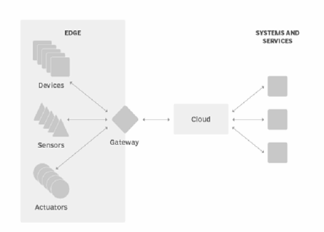

Fig:4.7.1. gateway block diagram

4.7.**2. Types of gateways:**

Gateways can take several forms and perform a variety of tasks. Examples of this include:

* [Web application firewalls](https://www.techtarget.com/searchsecurity/definition/Web-application-firewall-WAF)- This type filters traffic to and from a web server and looks at application-layer data.
* [Cloud storage gateways](https://www.techtarget.com/searchstorage/definition/cloud-storage-gateway)- This type translates storage requests with various cloud storage service API calls. It allows organizations to integrate storage from a private cloud into applications without migrating into a public cloud.
* [API](https://www.techtarget.com/searchapparchitecture/definition/application-program-interface-API), [SOA](https://www.techtarget.com/searchapparchitecture/definition/service-oriented-architecture-SOA) or XML gateways – This type manages traffic flowing into and out of a service, microservices-oriented architecture or XML-based web service.
* IoT gateways-This type aggregates sensor data from devices in an IoT environment, translates between sensor protocols and processes sensor data before sending it onward.
* [Media gateways](https://www.techtarget.com/searchunifiedcommunications/definition/media-gateway)- This type converts data from the format required for one type of network to the format required for another.
* Email security gateways- This type prevents the transmission of emails that break company policy or will transfer information with malicious intent.
* [VoIP trunk gateways](https://www.techtarget.com/searchunifiedcommunications/definition/VoIP-trunk-gateway)- This type facilitates the use of plain old telephone service equipment, such as landline phones and fax machines, with a voice over IP (VoIP) network.

**4.7.3. The Differences Between Internet Connections:**

When determining which type of [Internet speed](https://www.xfinity.com/hub/internet/internet-speed)and [Internet connection type](https://www.xfinity.com/hub/internet/dsl-vs-cable) is right for you or your family, it's important to understand the distinction between each connection. In today's age, there are numerous ways to connect laptops, desktops, mobile phones, gaming consoles, e-readers and tablets to the Internet. Some of the most widely used Internet connections are described below.

**4.7.3.1. MOBILE:**

Many cellphone and smartphone providers offer voice plans with Internet access. Mobile Internet connections provide good speeds and allow you to access the [Internet](https://www.xfinity.com/hub/internet/internet-on-the-go).

#### **4.7.3.2. WIFI hotspots:**

Wi-fi Hotspots are sites that offer Internet access over a wireless local area network (WLAN) by way of a router that then connects to an Internet service provider. Hotspots utilize [Wi-Fi](https://www.xfinity.com/learn/internet-service/wifi) technology, which allows electronic devices to connect to the Internet or exchange data wirelessly through radio waves. Hotspots can be phone-based or free-standing, commercial or free to the public.

#### **4.7.3.3. DIAL-UP:**

Dial-up connections require users to link their phone line to a computer in order to access the Internet. This particular type of connection also referred to as analog does not permit users to make or receive phone calls through their [home phone service](https://www.xfinity.com/learn/home-phone-services) while using the Internet. Now more outdated, a dial-up connection used to be among the most common Internet connection type.

#### **4.7.3.4. BROADBAND:**

This high-speed Internet connection is provided through either cable or telephone companies. One of the fastest options available, broadband Internet uses multiple data channels to send large quantities of information. The term broadband is shorthand for broad bandwidth. Broadband Internet connections such as DSL and cable are considered high-bandwidth connections. Although many DSL connections can be considered broadband, not all broadband connections are DSL.

#### **4.7.3.5. DSL:**

DSL, which stands for Digital Subscriber Line, uses existing 2-wire copper telephone line connected to one's home so service is delivered at the same time as landline telephone service. Customers can still place calls while surfing the Internet.

#### **4.7.3.6. CABLE:**

Cable Internet connection is a form of broadband access. Through use of a cable modem, users can access the Internet over cable TV lines. Cable modems can provide extremely fast access to the Internet, making a cable connection a viable option for many.

**4.7.3.7. SATELLITE:**

In certain areas where broadband connection is not yet offered, a satellite Internet option may be available. Similar to wireless access, satellite connection utilizes a modem.

**4.7.3.8. ISDN:**

ISDN (Integrated Services Digital Network) allows users to send data, voice and video content over digital telephone lines or standard telephone wires. The installation of an ISDN adapter is required at both ends of the transmission-on the part of the user as well as the Internet access provider.

There are quite a few other Internet connection options available, including T-1 lines, T-3 lines, OC (Optical Carrier) and other DSL technologies*.* Reliably fast speeds and comprehensive coverage make it easier than ever to stream your favorite TV shows and movies, share photos, chat with friends and play games online.

Xfinity is proud to support the Federal Government’s [Affordable Connectivity Program](https://www.xfinity.com/learn/internet-service/acp), a temporary subsidy program available for all tiers of Xfinity Internet service, including Internet Essentials. Learn more about the [ACP Program](https://www.xfinity.com/learn/internet-service/acp) to see if you qualify.

**4.8. WEIGHT SENSOR:**

Get to know the functionalities and capabilities of various weight sensors, also known as load cells, in this comprehensive guide.

**Weight Sensor**manufactured in US by FUTEK Advanced Sensor Technology (FUTEK), a leading manufacturer producing a huge selection of **Weight Transducers**, utilizing one of the most advanced technologies in the Sensor Industry: Metal foil **strain gauge** technology. A **Weight Transducer**is defined as a transducer that converts an input mechanical **load, weight, tension, compression or pressure**into an electrical output signal (load cell definition). Weight Sensors are also commonly known as Weight Transducer. There are several types of load cells based on size, geometry and capacity.

By definition, a weight sensor is a type of transducer, specifically a weight transducer. It converts an input mechanical force such as load, weight, tension, compression, or pressure into another physical variable, in this case, into an electrical output signal that can be measured, converted and standardized. As the force applied to the sensor increases, the electrical signal changes proportionally.

Weight Transducers became an essential element in many industries from Automotive, High precision manufacturing, Aerospace & Defense, Industrial Automation, Medical & Pharmaceuticals, and Robotics where reliable and high precision measurement is paramount. Most recently, with the advancements in Collaborative Robots (Cobots) and Surgical Robotics, many novel weight measurement application**s** are emerging.

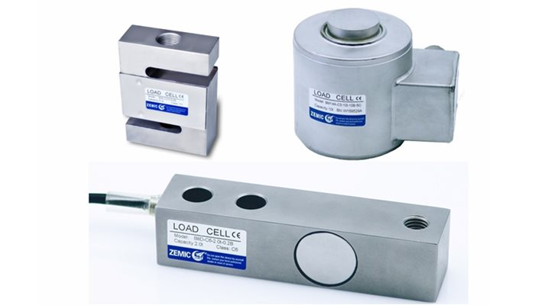

Fig 4.8 Weight sensor

**4.8.1. Weight Sensor Work:**

Firstly, we need to understand the underlying physics and material science behind the strain **weight measurement working principle,** which is the **strain gauge** (sometimes referred to as **Strain gage**). Metal foil strain gage is a sensor whose electrical resistance varies with applied force. In other words, it converts (or transduces) force, pressure, tension, compression, torque, weight, etc… into a change in electrical resistance, which can then be measured.

**4.9. POWER SUPPLY:**

The rectifier circuit is used to convert the AC (Alternating Current) into DC (Direct Current). Rectifiers are mainly classified into three types namely half-wave, full-wave, and bridge rectifier. The main function of all these rectifiers is the same as the conversion of current but they not efficiently convert the current from AC to DC. The center tapped full wave rectifier as well as bridge rectifier converts efficiently. A bridge rectifier circuit is a common part of the electronic power supplies. Many[electronic circuits](https://www.elprocus.com/build-your-own-electronic-circuits-for-simple-applications/) require a rectified DC [power supply](https://www.elprocus.com/types-power-supplies/) for powering the various [electronic basic components](https://www.elprocus.com/basic-components-used-electronics-electrical/) from available AC mains supply. We can find this rectifier in a wide variety of electronic [AC power devices like home appliances](https://www.elprocus.com/ac-power-supplies-home/), motor controllers, modulation process, welding applications, etc. This article discusses an overview of a bridge rectifier and its working.

**4.10. Bridge Rectifier:**

A Bridge rectifier is an Alternating Current (AC) to Direct Current (DC) converter that rectifies mains AC input to DC output. Bridge Rectifiers are widely used in power supplies that provide necessary DC voltage for the electronic components or devices. They can be constructed with four or more diodes or any other controlled solid-state switches.

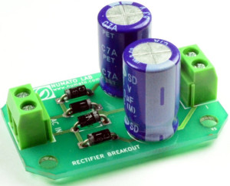

Fig4.10 Bridge Rectifier diagram

Depending on the load current requirements, a proper bridge rectifier is selected. Components’ ratings and specifications, breakdown voltage, temperature ranges, transient current rating, forward current rating, mounting requirements, and other considerations are taken into account while selecting a rectifier power supply for an appropriate electronic circuit’s application.

### **4.10.1. Construction:**

The bridge rectifier construction is shown below. This circuit can be designed with four diodes namely D1, D2, D3 & D4 along with a load resistor (RL). The connection of these diodes can be done in a closed-loop pattern to convert the AC (alternating current) to DC (Direct Current) efficiently. The main benefit of this design is the lack of an exclusive center-tapped transformer. So, the size, as well as cost, will be reduced.

Once the input signal is applied across the two terminals like A & B then the o/p DC signal can be attained across the RL. Here load resistor is connected in between two terminals like C & D. The arrangement of two diodes can be made in such a way that the electricity will be conducted by two diodes throughout every half cycle. The pairs of diodes like D1& D3 will conduct electric current throughout the positive half cycle. Similarly, D2 & D4 diodes will conduct electric current throughout a negative half cycle.

### **4.10.2. Bridge Rectifier Circuit Diagram:**

The main advantage of the bridge rectifier is that it produces almost double the output voltage as with the case of a full-wave rectifier using a center-tapped transformer. But this circuit doesn’t need a center-tapped transformer so it resembles a low-cost rectifier.

The bridge rectifier circuit diagram consists of various stages of devices like a transformer, Diode Bridge, filtering, and regulators. Generally, all these blocks combination is called a [regulated DC power supply](https://www.elprocus.com/step-step-guide-build-electronic-circuit/) that powers various electronic appliances.

The first stage of the circuit is a transformer which is a step-down type that changes the amplitude of the input voltage. Most of the [electronic projects](https://www.elprocus.com/latest-electronics-projects-ideas/) use a 230/12V transformer to step-down the AC mains 230V to 12V AC supply. The next stage is a diode-bridge rectifier which uses four or more diodes depending on the type of bridge rectifier. Choosing a particular diode or any other switching device for a corresponding rectifier needs some considerations of the device like Peak Inverse Voltage (PIV), forward current If, voltage ratings, etc. It is responsible for producing unidirectional or DC current at the load by conducting a set of diodes for every half cycle of the input signal.

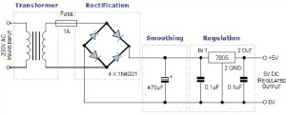

4.10.2 Bridge Rectifier Circuit Diagram

Since the output after the diode bridge rectifiers is of pulsating nature, and for producing it as a pure DC, filtering is necessary. Filtering is normally performed with one or more [capacitors attached across](https://www.elprocus.com/capacitors-types-applications/) the load, as you can observe in the below figure wherein smoothing of the wave is performed. This capacitor rating also depends on the output voltage.

The last stage of this regulated DC supply is a voltage regulator that maintains the output voltage to a constant level. Suppose the [microcontroller works](https://www.elprocus.com/microcontrollers-types-and-applications/) at 5V DC, but the output after the bridge rectifier is around 16V, so to reduce this voltage, and to maintain a constant level – no matter voltage changes in the input side – a voltage regulator is necessary.

**4.10.3. Bridge Rectifier Operation:**

As we discussed above, a single-phase bridge rectifier consists of four diodes and this configuration is connected across the load. For understanding the bridge rectifier’s working principle, we have to consider the below circuit for demonstration purposes. During the Positive half cycle of the input AC waveform diodes, D1 and D2 are forward biased and D3 and D4 are reverse biased. When the voltage, more than the[threshold level of the diodes](https://www.elprocus.com/types-of-diodes-and-applications/) D1 and D2, starts conducting – the load current starts flowing through it, as shown in the path of the red line in the diagram below.

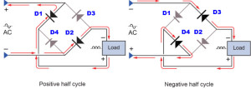

Fig 4.10.3: Circuit Operation

During the negative half cycle of the input AC waveform, the diodes D3 and D4 are forward biased, and D1 and D2 are reverse biased. Load current starts flowing through the D3 and D4 diodes when these diodes start conducting as shown in the figure.

We can observe that in both cases, the load current direction is the same, i.e., up to down as shown in the figure – so unidirectional, which means DC current. Thus, by the usage of a bridge rectifier, the input AC current is converted into a DC current. The output at the load with this bridge wave rectifier is pulsating in nature, but producing a pure DC requires an additional filter like a capacitor. The same operation is applicable for different bridge rectifiers, but in the case of controlled rectifiers [thyristors triggering](https://www.elprocus.com/diac-in-power-control-systems/) is necessary to drive the current to load. **4.10.4. Types of Bridge Rectifiers:**

Bride rectifiers are classified into several types based on these factors: type of supply, controlling capability, bride circuit configurations, etc. Bridge rectifiers are mainly classified into single and three-phase rectifiers. Both these types are further classified into uncontrolled, half controlled, and full controlled rectifiers. Some of these types of rectifiers are described below.

**4.10.5. Single Phase and Three Phase Rectifiers:**

The nature of supply, i.e., a single-phase or three-phase supply decides these rectifiers. The Single-phase bridge rectifier consists of four diodes for converting AC into DC, whereas a [three-phase rectifier uses six diodes](https://www.elprocus.com/brief-explaination-about-working-of-vfds/), as shown in the figure. These can be again uncontrolled or controlled rectifiers depending on the circuit components such as diodes, thyristors, and so on.

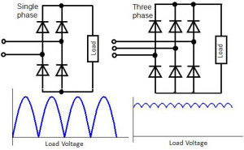

Fig 4.10.5: Single Phase and Three Phase Rectifiers

**4.10.6. Uncontrolled Bridge Rectifiers.**

This bridge rectifier uses diodes for rectifying the input as shown in the figure. Since the diode is a unidirectional device that allows the current flow in one direction only. With this configuration of diodes in the rectifier, it doesn’t allow the power to vary depending on the load requirement. So, this type of rectifier is used in [constant or fixed power supplies](https://www.elprocus.com/types-power-supplies/).

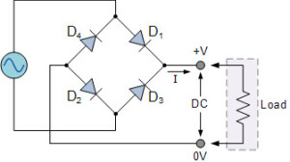

Fig 4.10.6: Uncontrolled Bridge Rectifiers

**4.10.7. Controlled Bridge Rectifier:**

In this type of rectifier, [AC/DC converter or rectifier](https://www.elprocus.com/power-electronic-converters/) – instead of uncontrolled diodes, controlled solid-state devices like SCR’s, MOSFET’s, IGBT’s, etc. are used to vary the output power at different voltages. By triggering these devices at various instants, the output power at the load is appropriately changed.

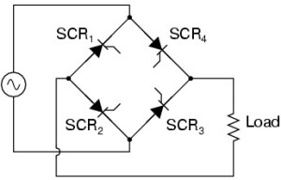

Fig 4.10.7: Controlled Bridge Rectifier

### **4.10.8. Bridge Rectifier IC:**

The sub categories of this RB-15 Bridge rectifier range from RB15 to RB158. Out of these rectifiers, the RB156 is the most frequently used one. The specifications of the RB-156 bridge rectifier include the following.

* O/p DC current is 1.5A
* The maximum peak reverse voltage is 800V

This RB-156 is most normally used compact, low cost and single-phase bridge rectifier. This IC has the highest i/p AC voltage like 560V therefore it can be used for 1- phase mains supply in all countries. The highest DC current of this rectifier is 1.5A.

This IC is the best choice in the projects for converting AC-DC and provide up to 1.5A. A computer that sits between different networks or application. The gateway converts information, data or other communication from one protocol or format to another.

An internet gateway can transfer communication between an enterprise network and the internet. The default gateway is the path used to pass information when the device doesn’t know where the destination is. More directly, a default gateway is a router that connects your host to remote network segment.

The bridge rectifier just discussed is a single-phase type, however, it can also be extended to a three-phase rectifier. These two types can be further classified into full controlled, half controlled, or uncontrolled bridge rectifiers. The circuit that we just discussed is uncontrolled since we cannot control the biasing of the diode, but if all the four diodes are replaced with a thyristor, its biasing can be controlled by controlling its firing angle via its gate signal. It results in a fully controlled bridge rectifier. In a half-Controlled bridge rectifier, half of the circuit contains diodes, and the other half has thyristors.

The bridge rectifier just discussed is a single-phase type, however, it can also be extended to a three-phase rectifier. These two types can be further classified into full controlled, half controlled, or uncontrolled bridge rectifiers. The circuit that we just discussed is uncontrolled since we cannot control the biasing of the diode, but if all the four diodes are replaced with a thyristor, its biasing can be controlled by controlling its firing angle via its gate signal. It results in a fully controlled bridge rectifier. In a half-controlled bridge rectifier, half of the circuit contains diodes, and the other half has thyristors.

**CHAPTER 5**

**ARDUINO MICROCONTROLLER**

### **5.1. Overview:**

**Arduino** is a microcontroller board based on 8-bit ATmega328P microcontroller. Along with ATmega328P, it consists other components such as crystal oscillator, serial communication, voltage regulator, etc. to support the microcontroller. Arduino Uno has 14 digital input/output pins (out of which 6 can be used as PWM outputs), 6 analog input pins, a USB connection, A Power barrel jack, an ICSP header and a reset button.

[Arduino](http://arduino.cc/) is an open-source platform used for building electronics projects. Arduino consists of both a physical programmable circuit board (often referred to as a [microcontroller](http://en.wikipedia.org/wiki/Microcontroller)) and a piece of [software](http://arduino.cc/en/Main/Software), or IDE (Integrated Development Environment) that runs on your computer, used to write and upload computer code to the physical board.

The Arduino platform has become quite popular with people just starting out with electronics, and for good reason. Unlike most previous programmable circuit boards, the Arduino does not need a separate piece of hardware (called a programmer) in order to load new code onto the board -- you can simply use a USB cable. Additionally, the Arduino IDE uses a simplified version of C++, making it easier to learn to program. Finally, Arduino provides a standard form factor that breaks out the functions of the micro-controller into a more accessible package.

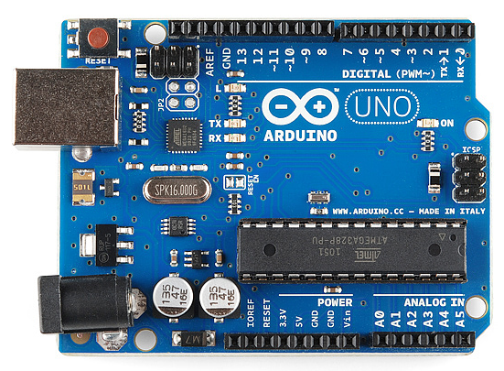

Fig 5.1: Arduino diagram

The Uno is one of the more popular boards in the Arduino family and a great choice for beginners. We'll talk about what's on it and what it can do later in the tutorial The Arduino hardware and software was designed for artists, designers, hobbyists, hackers, newbies, and anyone interested in creating interactive objects or environments. Arduino can interact with buttons, LEDs, motors, speakers, GPS units, cameras, the internet, and even your smart-phone or your TV! This flexibility combined with the fact that the Arduino software is free, the hardware boards are pretty cheap, and both the software and hardware are easy to learn has led to a large community of users who have contributed code and released instructions for a **huge** variety of Arduino-based projects. For everything from [robots](https://learn.sparkfun.com/tutorials/building-the-hub-ee-buggy) and a [heating pad hand warming blanket](https://learn.sparkfun.com/tutorials/heating-pad-hand-warmer-blanket) to [honest fortune-telling machines](https://learn.sparkfun.com/tutorials/the-uncertain-7-cube), and even a [Dungeons and Dragons dice-throwing gauntlet](http://www.sparkfun.com/tutorials/333), the Arduino can be used as the brains behind almost any electronics project.

**5.2: Arduino Architecture:**

Arduino’s processor basically uses the Harvard architecture where the program code and program data have separate memory. It consists of two memories- Program memory and the data memory. The code is stored in the flash program memory, whereas the data is stored in the data memory. The Atmega328 has 32 KB of flash memory for storing code (of which 0.5 KB is used for the bootloader), 2 KB of SRAM and 1 KB of EEPROM and operates with a clock speed of 16MHz.

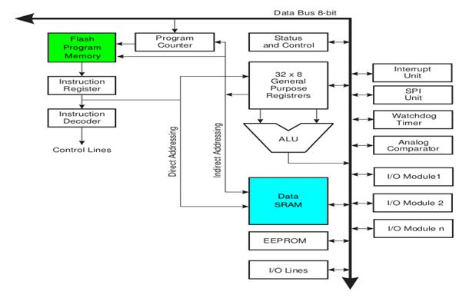

Fig: 5.2: Arduino Architecture

**5.3: Arduino Pin Diagram:**

A typical example of Arduino board is Arduino Uno. It consists of ATmega328- a 28 pin microcontroller.

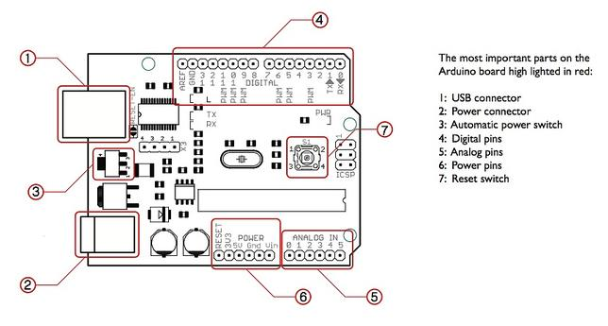

Fig:5.3: Arduino Pin Diagram

Arduino Uno consists of 14 digital input/output pins (of which 6 can be used as PWM outputs), 6 analog inputs, a 16 MHz crystal oscillator, a USB connection, a power jack, an ICSP header, and a reset button.

**5.3.1: Power Jack**:

Arduino can be power either from the pc through a USB or through external source like adaptor or a battery. It can operate on a external supply of 7 to 12V. Power can be applied externally through the pin Vin or by giving voltage reference through the IORef pin.

**5.3.2: Digital Inputs**:

It consists of 14 digital inputs/output pins, each of which provide or take up 40mA current. Some of them have special functions like pins 0 and 1, which act as Rx and Tx respectively, for serial communication, pins 2 and 3-which are external interrupts, pins 3,5,6,9,11 which provides pwm output and pin 13 where LED is connected.

**5.3.3: Analog inputs**:

It has 6 analog input/output pins, each providing a resolution of 10 bits.

### Basic Adruino functions are:

* **digitalRead**(pin): Reads the digital value at the given pin.
* **digitalWrite** (pin, value): Writes the digital value to the given pin.
* **pin Mode** (pin, mode): Sets the pin to input or output mode.
* **analog Read**(pin): Reads and returns the value.
* **analog Write** (pin, value): Writes the value to that pin.
* **serial. Begin** (baud rate): Sets the beginning of serial communication by setting the bit rate.

**5.3.4: Arduino Specification:**

* Microcontroller: ATmega328P
* Operating Voltage: 5V
* Input Voltage (recommended): 7-12V
* Input Voltage (limit): 6-20V
* Digital I/O Pins: 14 (of which 6 provide PWM output)
* PWM Digital I/O Pins: 6
* Analog Input Pins: 6
* DC Current per I/O Pin: 20 mA
* DC current for 3.3V Pin: 50 mA
* Flash Memory: 32 KB (ATmega328P) of which 0.5 KB used by bootloader
* SRAM: 2 KB (ATmega328P)
* EEPROM: 1 KB (ATmega328P)
* Clock Speed: 16 MHz

PWM stands for Pulse Width Modulation and it is a technique used in controlling the brightness of LED, speed control of DC motor, controlling a servo motor or where you have to get analog output with digital means.

The Arduino digital pins either gives us 5V (when turned HIGH) or 0V (when turned LOW) and the output is a square wave signal. So, if we want to dim a LED, we cannot get the voltage between 0 and 5V from the digital pin but we can change the ON and OFF time of the signal. If we will change the ON and OFF time fast enough then the brightness of the led will be changed.

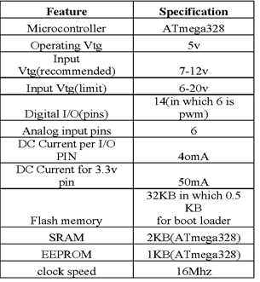

Table :5.3.4: Arduino uno specification

**5.3.4.1: ATmega328:**

The  ATmega328 is a single-[chip](https://en.m.wikipedia.org/wiki/Integrated_circuit) [microcontroller](https://en.m.wikipedia.org/wiki/Microcontroller) created by [Atmel](https://en.m.wikipedia.org/wiki/Atmel) in the [megaAVR](https://en.m.wikipedia.org/wiki/MegaAVR) family (later [Microchip Technology](https://en.m.wikipedia.org/wiki/Microchip_Technology) acquired Atmel in 2016). It has a [modified Harvard architecture](https://en.m.wikipedia.org/wiki/Modified_Harvard_architecture) [8-bit](https://en.m.wikipedia.org/wiki/8-bit) [RISC](https://en.m.wikipedia.org/wiki/Reduced_instruction_set_computer) processor core. is a single-[chip](https://en.m.wikipedia.org/wiki/Integrated_circuit) [microcontroller](https://en.m.wikipedia.org/wiki/Microcontroller) created by [Atmel](https://en.m.wikipedia.org/wiki/Atmel) in the [megaAVR](https://en.m.wikipedia.org/wiki/MegaAVR) family (later [Microchip Technology](https://en.m.wikipedia.org/wiki/Microchip_Technology) acquired Atmel in 2016). It has a [modified Harvard architecture](https://en.m.wikipedia.org/wiki/Modified_Harvard_architecture) [8-bit](https://en.m.wikipedia.org/wiki/8-bit) [RISC](https://en.m.wikipedia.org/wiki/Reduced_instruction_set_computer) processor core.

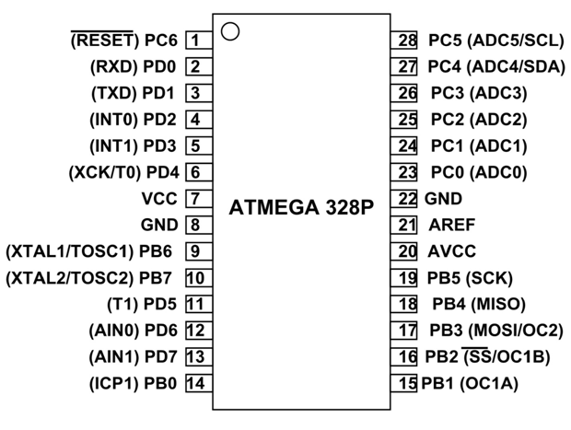

Fig: 5.3.4.1: ATmega328P diagram

The Atmel [8-bit](https://en.m.wikipedia.org/wiki/8-bit) [AVR](https://en.m.wikipedia.org/wiki/Atmel_AVR) [RISC](https://en.m.wikipedia.org/wiki/Reduced_instruction_set_computing)-based microcontroller combines 32 KB [ISP](https://en.m.wikipedia.org/wiki/In-system_programming) [flash](https://en.m.wikipedia.org/wiki/Flash_memory) memory with read-while-write capabilities, 1 KB [EEPROM](https://en.m.wikipedia.org/wiki/EEPROM), 2 KB [SRAM](https://en.m.wikipedia.org/wiki/Static_random-access_memory), 23 general-purpose I/O lines, 32 general-purpose working [registers](https://en.m.wikipedia.org/wiki/Processor_register), 3 flexible timer/[counters](https://en.m.wikipedia.org/wiki/Counter_(digital)) with compare modes, internal and external [interrupts](https://en.m.wikipedia.org/wiki/Interrupt), serial programmable [USART](https://en.m.wikipedia.org/wiki/USART), a byte-oriented 2-wire serial interface, [SPI](https://en.m.wikipedia.org/wiki/Serial_Peripheral_Interface_Bus) serial port, 6-channel 10-bit [A/D converter](https://en.m.wikipedia.org/wiki/A/D_converter) (8 channels in [TQFP](https://en.m.wikipedia.org/wiki/Quad_Flat_Package) and [QFN](https://en.m.wikipedia.org/wiki/Quad_Flat_No-leads_package)/[MLF](https://en.m.wikipedia.org/wiki/Quad-flat_no-leads_package#Variants) packages), programmable [watchdog timer](https://en.m.wikipedia.org/wiki/Watchdog_timer) with internal [oscillator](https://en.m.wikipedia.org/wiki/Electronic_oscillator), and 5 software-selectable power-saving modes. The device operates between 1.8 and 5.5 volts. The device achieves throughput approaching 1 [MIPS](https://en.m.wikipedia.org/wiki/Million_instructions_per_second#Million_instructions_per_second)/MHz.

**5.3.4.2: Operating voltage:**

For example, some logic circuits operate at 5V whereas others operate at 3.3V. Directly interfacing a 5V logic output to a 3.3V input. the operating system) can use to adjust the clock speed and core voltage dynamically. Often a voltage regulator module converts from 5V or 12 V or some. the DC power jack (7 - 20V), the USB connector (5V), or the VIN pin of the board (7-20V). Supplying voltage via the 5V or 3.3V pins bypasses the regulator. If you apply 5 volts power supply, the UNO won't be able to regulate to 5 volts. The voltage regulator itself will have a voltage drop, and the UNO will operate at less than 5 volts. The UNO may or may not operate properly. The USB will likely suffer from more problems than the UNO if you apply 5 volts. The Arduino Uno Rev3 has an OpAmp (TI LMV358IDGKR [datasheet](https://www.ti.com/lit/gpn/LMV358)) where the non-inverting input ("CMP") is connected via a voltage divider to Vin. The OpAmp’s supply is connected to 5v.

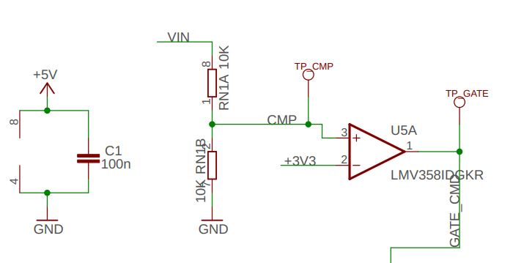

Fig 5.3.4.2: operating voltage diagram

**5.3.4.3: DIGITAL I/O PINS. 14:**

The board has 14 digital I/O pins (six capable of PWM output. 6 analog I/O pins and is programmable with the Arduino IDE via a type B USB cable.

### **5.3.4.4: What is PWM:**

PWM stands for Pulse Width Modulation and it is a technique used in controlling the brightness of LED, speed control of DC motor, controlling a servo motor or where you have to get analog output with digital means.

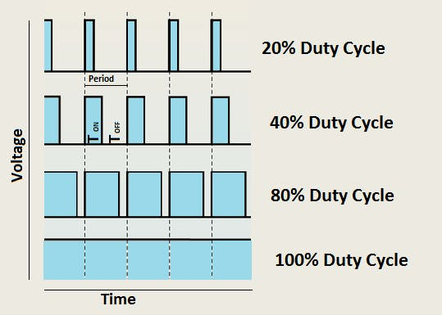

Fig 5.3.4.4: PWM diagram

### **5.3.4.5: Arduino and PWM:**

The Arduino IDE has a built-in function “analog Write ()” which can be used to generate a PWM signal. The frequency of this generated signal for most pins will be about 490Hz and we can give the value from 0-255 using this function.

Analog Write (0) means a signal of 0% duty cycle.

Analog Write (127) means a signal of 50% duty cycle.

Analog Write (255) means a signal of 100% duty cycle.

On Arduino Uno, the PWM pins are 3, 5, 6, 9, 10 and 11. The frequency of PWM signal on pins 5 and 6 will be about 980Hz and on other pins will be 490Hz. The PWM pins are labeled with ~ sign.

### **5.3.4.6: Controlling Brightness of LED Through Code:**

Connect the positive leg of LED which is the longer leg to the digital pin 6 of Arduino. Then connect the 220ohm resistor to the negative leg of LED and connect the other end of resistor to the ground pin of Arduino.

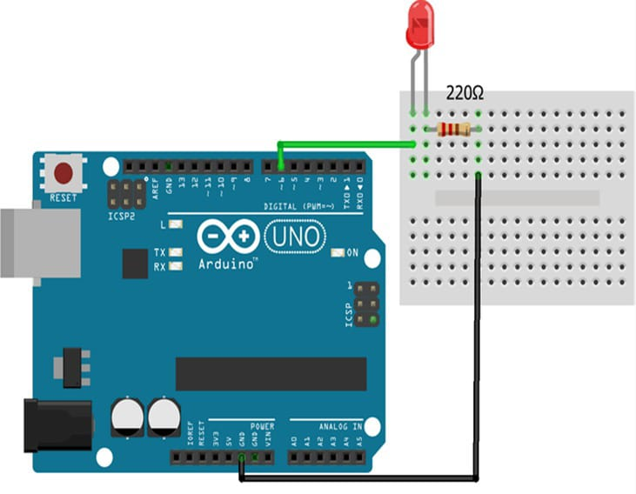

Fig 5.3.4.6: LED diagrams

## **5.3.4.7: EEPROM**

EEPROM also written E2PROM is a type of non-volatile memory is a non-volatile memory used to store relatively small amounts of data that can allow individual bytes to be erased & reprogrammed. EEPROM / E2PROM technology was one of the first forms of non-volatile semiconductor memory chip. Its development came out of the standard EPROM technology that was widespread in the late 1970s and 1980s. These EPROM memories could be programmed, typically with machine software, and then later erased by exposing the chip to UV light if the software needed to be changed.

Although the erasure process took an hour or so, this was quite acceptable for development environments. However, these semiconductor memories could not be erased electrically, and a totally electrical arrangement would have been more convenient. EEPROM (also called E2PROM) stands for electrically erasable programmable read-only memory and is a type of [non-volatile memory](https://en.m.wikipedia.org/wiki/Non-volatile_memory) used in computers, integrated in [microcontrollers](https://en.m.wikipedia.org/wiki/Microcontrollers) for [smart cards](https://en.m.wikipedia.org/wiki/Smart_card) and [remote keyless systems](https://en.m.wikipedia.org/wiki/Remote_keyless_system), and other electronic devices to store relatively small amounts of data by allowing individual bytes to be erased and reprogrammed.

[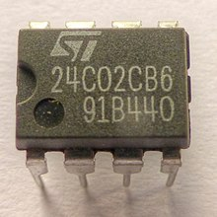](https://en.m.wikipedia.org/wiki/File:AT24C02_EEPROM_1480355_6_7_HDR_Enhancer.jpg)

Fig 5.3.4.7: EEPROM diagram

EEPROMs are organized as arrays of [floating-gate transistors](https://en.m.wikipedia.org/wiki/Floating-gate_transistor). EEPROMs can be programmed and erased in-circuit, by applying special programming signals. Originally, EEPROMs were limited to single-byte operations, which made them slower, but modern EEPROMs allow multi-byte page operations. An EEPROM has a limited life for erasing and reprogramming, now reaching a million operations in modern EEPROMs. In an EEPROM that is frequently reprogrammed, the life of the EEPROM is an important design consideration.

## **5.3.4.8: SRAM (static random-access memory):**

## SRAM (static RAM) is a type of random-access memory (RAM) that retains data bits in its memory as long as power is being supplied. Unlike dynamic RAM (DRAM), which must be continuously refreshed, SRAM does not have this requirement, resulting in better performance and lower power usage. However, SRAM is also more expensive than DRAM, and it requires a lot more space.

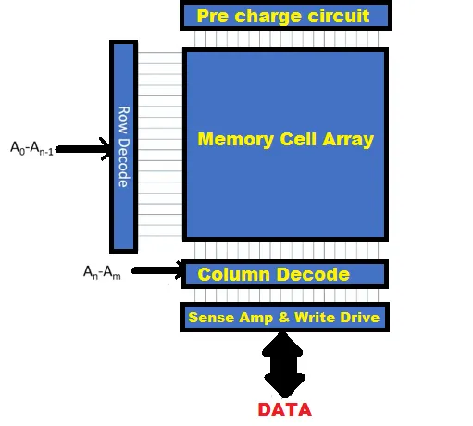

Fig 5.3.4.8: SRAM diagram

## SRAM is commonly used for a computer's cache memory, such as a processor's L2 or L3 cache. It is not used for a computer's main memory because of its cost and size. Most computers use DRAM instead because it supports greater densities at a lower cost per megabyte (MB). However, SRAM is often used for other purposes. For example, it might be part of a RAM digital-to-analog converter (RAMDAC) on a computer's video or graphic card. It might also be used in a disk drive as buffer cache, in a peripheral such as a printer or LCD display, or in a network device such as router or switch. SRAM can be found in other devices ways as well. For example, SRAM chips are often used in cell phones, wearables and other consumer electronics. They might also be embedded in medical products, which can include anything from hearing aids to body area networks that include multiple devices embedded in the body. In addition, SRAM is used in toys, appliances, automobiles, industrial equipment and a wide range of IoT devices. Both SRAM and DRAM are types of nonvolatile memory, which means they lose their data if the power goes out. Despite this similarity, they differ in important ways Much of this difference lies in how they're constructed. SRAM uses a flip-flop circuit to store each data bit.

## The circuit delivers two stable states, which are read as 1 or 0. To support these states, the circuit requires six transistors, four to store the bit and two to control access to the cell. Because of all these transistors, a SRAM chip has a much lower capacity that a DRAM chip of comparable size. DRAM requires only one transistor and one capacitor to store a bit. The capacitor holds the electrons that determine whether the bit is a 0 or 1.

## 

**CHAPTER 6**

**RESULT**

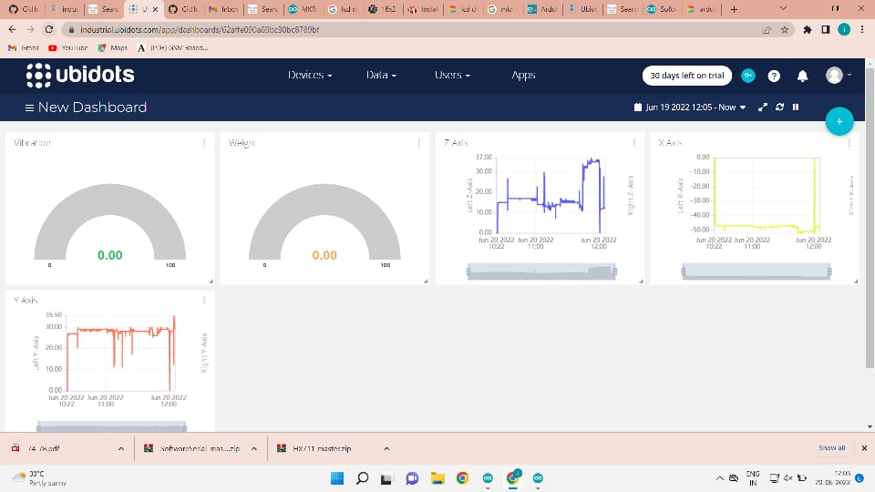

Ubidots provides a secure and easy way to build IoT solutions for students, makers and researchers. It is used for sending data from any internet enabled device to the cloud, triggering actions and alerts based on that data, and visualizing it.

**CHAPTER 7**

**CONCLUSION**

Nowadays, the ability to monitor the integrity of a wide variety of buildings with low-cost and real-time measurements is essential from both an economic and a life-safety standpoint. In this work, we proposed a completely un tethered wireless sensor node specifically designed to support long-term modal analysis with long-range connectivity at low power consumption. The existing system has got the design of both hardware and software, of a SHM node that can operate unattended for more 10 years, or even indefinitely with the support of external power source.

In this proposed system which provide a general overview of application especially in bridges, several case studies in the literatures demonstrate that MEMS technology has the potential to offer significant benefits to the civil engineering and transportation fields. A bridge monitoring is needed for public safety. Such system can be designed using TCP/IP protocol for connection between sensor and Arduino, Wi-Fi module to send data on the cloud server. The proposed system can also give notification about of bridge and some concrete problems time to time which will help or maintenance. In future similar system can be designed for building and railway monitoring IOT system with MEMS sensor technique is used to examine the lifetime, vibration of the bridge, strong, weakness and weight bearing capacity by using 3 axis MEMS accelerometer, in future this system can be implemented in railway bridges, high towers and apartments. We would like this project would come with success.

**REFERENCES**

[1] B. Romano, F. Zullo, L. Fiorini, A. Marucci, and S. Ciabo, “Land ` transformation of italy due to half a century of urbanization,” Land use policy, vol. 67, pp. 387–400, 2017.

[2] G. M. Calvi, M. Moratti, G. J. O’Reilly, N. Scattarreggia, R. Monteiro, D. Malomo, P. M. Calvi, and R. Pinho, “Once upon a time in italy: The tale of the morandi bridge,” Structural Engineering International, vol. 29, no. 2, pp. 198–217, 2019.

[3] C. A. Tokognon, B. Gao, G. Y. Tian, and Y. Yan, “Structural health monitoring framework based on internet of things: A survey,” IEEE Internet of Things Journal, vol. 4, no. 3, pp. 619–635, 2017

. [4] F. Zonzini, A. Girolami, L. De Marchi, A. Marzani, and D. Brunelli, “Cluster-based vibration analysis of structures with gsp,” IEEE Transactions on Industrial Electronics, vol. 68, no. 4, pp. 3465–3474, 2021.

[5] M. R. Dhage and S. Vemuru, “Structural health monitoring of railway tracks using wsn,” in 2017 International Conference on Computing, Communication, Control and Automation (ICCUBEA). IEEE, 2017, pp. 1–5.

[6] S. Valenti, M. Conti, P. Pierleoni, L. Zappelli, A. Belli, F. Gara, S. Carbonari, and M. Regni, “A low-cost wireless sensor node for building monitoring,” in 2018 IEEE Workshop on Environmental, Energy, and Structural Monitoring Systems (EESMS). IEEE, 2018, pp. 1–6.

[7] D. Catenazzo, B. O’Flynn, and M. Walsh, “On the use of wireless sensor networks in preventative maintenance for industry 4.0,” in 2018 12th International Conference on Sensing Technology (ICST). IEEE, 2018, pp. 256–262.

[8] A. Burrello, A. Marchioni, D. Brunelli, S. Benatti, M. Mangia, and L. Benini, “Embedded streaming principal components analysis for network load reduction in structural health monitoring,” IEEE Internet of Things Journal, vol. 8, no. 6, pp. 4433–4447, 2021.

[9] J. Haxhibeqiri, E. De Poorter, I. Moerman, and J. Hoebeke, “A survey of lorawan for iot: From technology to application,” Sensors, vol. 18, no. 11, p. 3995, 2018.

[10] M. Ballerini, T. Polonelli, D. Brunelli, M. Magno, and L. Benini, “Experimental evaluation on NB-IoT and lorawan for industrial and iot applications,” in 2019 IEEE 17th International Conference on Industrial Informatics (INDIN), vol. 1. IEEE, 2019, pp. 1729–1732.

[11] M. Ballerini, T. Polonelli, D. Brunelli, M. Magno, and L. Benini, “NBIoT vs. lorawan: An experimental evaluation for industrial applications,” IEEE Transactions on Industrial Informatics, 2020.

[12] H. Wang, P. Xiang, and L. Jiang, “Strain transfer theory of industrialized optical fiber-based sensors in civil engineering: A review on measurement accuracy, design and calibration,” Sensors and Actuators A: Physical, vol. 285, pp. 414–426, 2019.

[13] E. G. Popkova, “Preconditions of formation and development of industry 4.0 in the conditions of knowledge economy,” in Industry 4.0: Industrial Revolution of the 21st Century. Springer, 2019, pp. 65–72.

[14] A. Girolami, D. Brunelli, and L. Benini, “Low-cost and distributed health monitoring system for critical buildings,” in 2017 IEEE Workshop on Environmental, Energy, and Structural Monitoring Systems (EESMS), 2017, pp. 1–6.

. [15] A. Burrello, D. Brunelli, M. Malavisi, and L. Benini, “Enhancing structural health monitoring with vehicle identification and tracking,” in 2020 IEEE International Instrumentation and Measurement Technology Conference (I2MTC). IEEE, 2020, pp. 1–6.

[16] Y. Liao, A. Kiremidjian, R. Rajagopal, and C.-H. Loh, “Structural damage detection and localization with unknown post-damage feature distribution using sequential change-point detection method,” Journal of Aerospace Engineering Vol. 32, Issue 2, 11 2018.

[20] F. Zonzini, M. M. Malatesta, D. Bogomolov, N. Testoni, A. Marzani, and L. De Marchi, “Vibration-based shm with upscalable and low-cost sensor networks,” IEEE Transactions on Instrumentation and Measurement, vol. 69, no. 10, pp. 7990–7998, 2020.